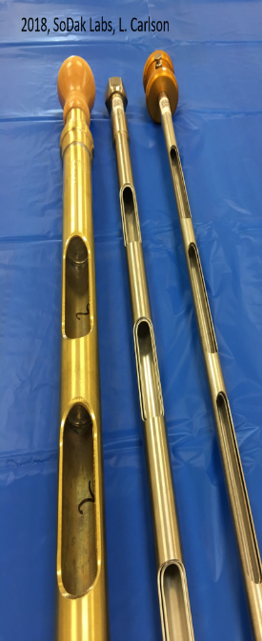
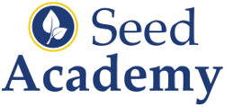
SA231
Seed Sampling Course
March 2019

Improve Your Understanding of Seed Sampling Methods
Gain knowledge in seed sampling and become an “Authorized Seed Sampler” for ISTA (International Seed Testing Association) Orange Certificates by participating in our NEW 2019 Seed Sampling Online Series. This is an educational course targeting seed production or laboratory staff involved in seed sampling who desire a better understanding of principles and concepts. The course is designed to allow participants to choose their level of achievement.
Option 1
Learn the basics of seed sampling, sampling intensity, equipment uses, and sample submission techniques for collecting samples that are representative of the seed lot and ISTA Orange certificates. There will be four (4) one-hour online classes. Participants will be provided a “Seed Sampling Manual” based off the Association of Official Seed Analysts (AOSA) and International Rules for Testing Seed (ISTA). Participants will complete an online exam at their location. Join us from 10:00-11:00 AM CST on the following dates.
March 6  Concepts & Definitions of Sampling | March 13  Sampling Intensity & practical examples
March 20  Demonstration and discussion of probes | March 27  Preparation of Submitted Sample

Option 2
Online course, written exam and on-site session to experience seed sampling with different species and containers. Complete a practical exam on May 8 in Brookings, SD to become an “Authorized Seed Sampler” for ISTA Orange Certificates. Upon successful completion, the seed sampler will be able to draw and submit samples to SoDak Labs and other ISTA Accredited Laboratories for ISTA Orange Certificates as an “Authorized Seed Sampler”.

Course Fee: $250/location (includes sampling manual and two Seed Academy T-shirts or coffee flasks); If you desire becoming an Authorized Sampler enroll as an individual.
Please register by Friday, March 1, 2019.
Register by either: (1) Online at www.SeedAcademyOnline.com
(2) Call Jena Werpy at 605-692-2758
NAME: ______________________________________________ PHONE: _______________________________
COMPANY: __________________________________________________
- Bill my Account #______
- Credit Card
- Check
- T-Shirts S M L XL XXL (pick 2 sizes)
- Coffee Insulated Flasks (2)
ADDRESS: __________________________________________________
EMAIL: _______________________________________________________
SoDak Labs, Inc. 236 32nd Ave. Brookings, SD 57006 605-692-2758

